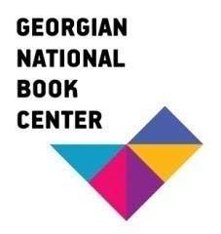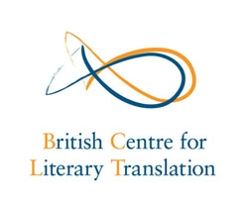

Literary Translation workshop

7th to 11th September 2015

Tbilisi, Georgia

APPLICATION FORM

□ I attach my CV
Name:

Address:

Telephone:

Email:

□ I attach a sample translation with the original text of Fiction (maximum 500 words per text)

□ Please tell us why you feel you would benefit from participating in the literary translation workshop
Please give details of your practical literary translation experience, any relevant academic qualifications, your enthusiasm and commitment to literary translation and how you will benefit from attendance at the literary translation workshop and use the skills in the future.

Signed……………………………………………… Date……………………

